Incident Lifecycle Automation in ServiceNow
3. Project Design Phase
3.1 Solution Architecture
The proposed solution uses ServiceNow's integrated modules to manage the complete incident lifecycle.
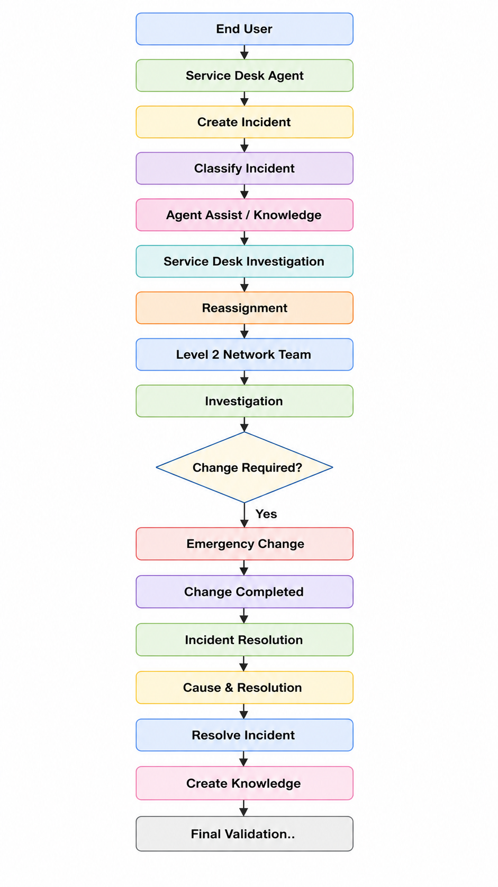
High-Level Flow:
3.2 Service Structure
The service hierarchy is designed as:
Remote Access
│
└── Corporate VPN
Where:
- Remote Access = Parent Service
- Corporate VPN = Service Offering

3.3 Incident Lifecycle Design
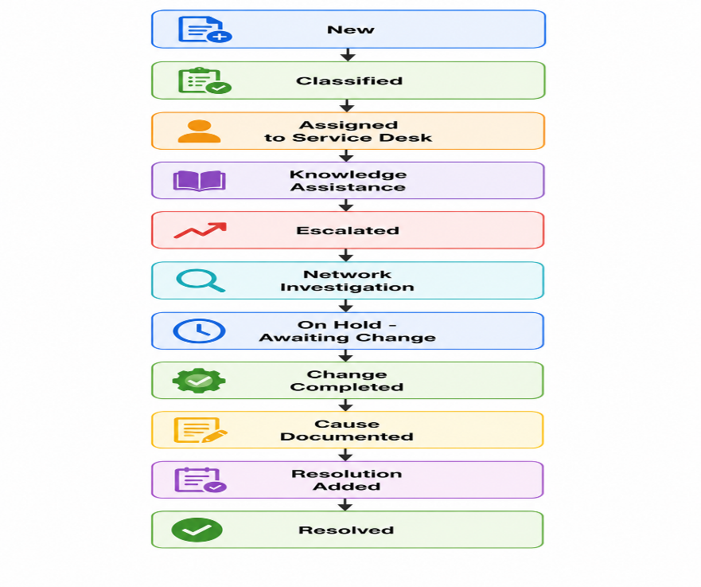
The incident lifecycle is designed as:
3.4 Stakeholder Design
Stakeholder | Role | Expectations | Impact of Automation
End Users | Report IT issues | Quick resolution and visibility | Faster resolution and transparent tracking
Service Desk Agents | First-level support | Easy logging and classification | Standardized intake and faster escalation
Level 2 Support | Diagnose and resolve issues | Complete incident information | Better diagnosis and clear ownership
Change Management Team | Manage emergency changes | Structured change requests | Integrated change control
ServiceNow Administrator | Maintain platform | Scalable and trackable solution | Controlled process management

3.5 Module Integration Design
The project integrates the following ServiceNow capabilities:
- Incident Management
- Knowledge Management
- Agent Assist
- Change Management
- Service Management
- Configuration Management
- SLA Management
- Related Lists
- Child Incidents

